**UNIVERSITY OF THE ARMED FORCES-ESPE**



**FUNDAMENTALS OF ENGINEERING**

**2021-2022**

**UNIT 2  
Software: enterprise resource planning**

**Software Requirement Specification**

**Enterprise Resource Planning**

Version 1.0 approved

Prepared by team 1

Chariboga Zurita Daniel Isai

Kleber Enrique Chavez Oscullo

Alcocer Marroquin Christian Daniel

Roberto Alexander Bedon Guevara

student of university ESPE

9-12-2021

Revision History

| **Name** | **Date** | **Reason For Changes** | **Version** |
| --- | --- | --- | --- |
|  |  |  |  |
|  |  |  |  |

**Index**

**1. Introduction** **4**

1.1 Purpose 4

1.2 Document Conventions 4

1.3 Intended Audience and Reading Suggestions 4

1.4 Product Scope 4

1.5 References 4

**2. Overall Description** **5**

2.1 Product Perspective 5

2.2 Product Functions 5

2.3 User Classes and Characteristics 5

2.4 Operating Environment 5

2.5 Design and Implementation Constraints 5

2.6 User Documentation 6

**4. System Features** **6**

4.1 System Feature 1 6

4.1.1 Description and Priority 6

4.1.2 Stimulus/Response Sequences 6

4.1.3 Functional Requirements 6

Requisitos Funcionales 6

Iniciar Sesión 6

4.2 System Feature 2 (and so on) 10

**5. Other Nonfunctional Requirements** **10**

5.1 Performance Requirements 10

5.2 Safety Requirements 10

5.3 Security Requirements 10

5.4 Software Quality Attributes 11

5.5 Business Rules 11

**6. Other Requirements** **11**

Appendix A: Glossary 11

Appendix B: Analysis Models 12

Appendix C: To Be Determined List 12

# **1.** **Introduction**

## 1.1 Purpose

It is a software program for a management company especially for the administrative and accounting part, in which we can search for information on prices, products, as well as information on personnel, clients and suppliers that belong to the company.

## 1.2 Document Conventions

In the words of the standard, the application has a broad and integrated database and server availability to meet the reduction in search time for documents and information, bearing in mind that it is the main problem to solve

## 1.3 Intended Audience and Reading Suggestions

This document is intended for business managers, business shareholders, developers, users, evaluators, and document writers.

Also this document contains an overview of the system, requirements, System Features,

Nonfunctional Requirements, The reader is encouraged to read the System Overview and Features first and then proceed with the requirements.

## 1.4 Product Scope

It is a software that is in charge of managing the financial data and statistics of a company, making it easier to keep accounts, declare taxes and have total control over statistics, sales, purchases, profits and losses, helping to focus on developing better sales and marketing methods to improve statistics

## 1.5 References

<https://economipedia.com/definiciones/software-de-gestion-empresarial.html#:~:text=Un%20software%20de%20gesti%C3%B3n%20empresarial,log%C3%ADstico%20e%20incluso%20de%20marketing>.

<https://www.zitelia.com/que-es-un-erp-y-para-que-se-utiliza/>

# 2. Overall Description

Companies need fast and reliable response time to meet both product, accounting, and distribution just how to move the human resources available to the company.the software will work in an intuitive and friendly interface way with a response rapids considered to be able to manage the different types of information must have an integrated database and connected to a network to be able to comonicarce with different departments of the company.

## 2.1 Product Perspective

Our product will replace many processes related to management within the company, in which we will realize that we will save time and we can both enter and search for data, as well as we can do an advanced search about what is needed to know.

## 2.2 Product Functions

Data of the products, workers, customers and suppliers will be entered into a database in which a brief review or search of what is necessary for both the client and the person in charge of the program can be made.

**2.2.1. Login**

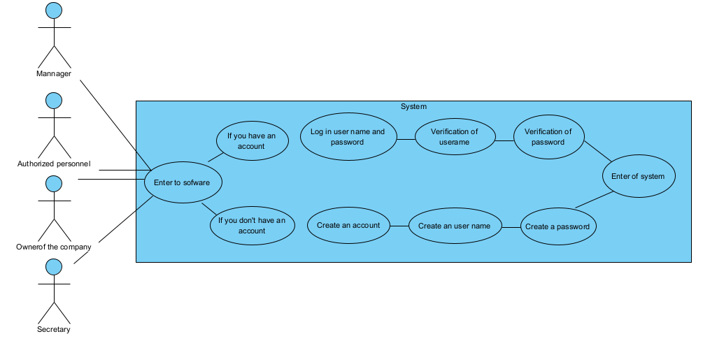

**2.2.2. Information storage system**

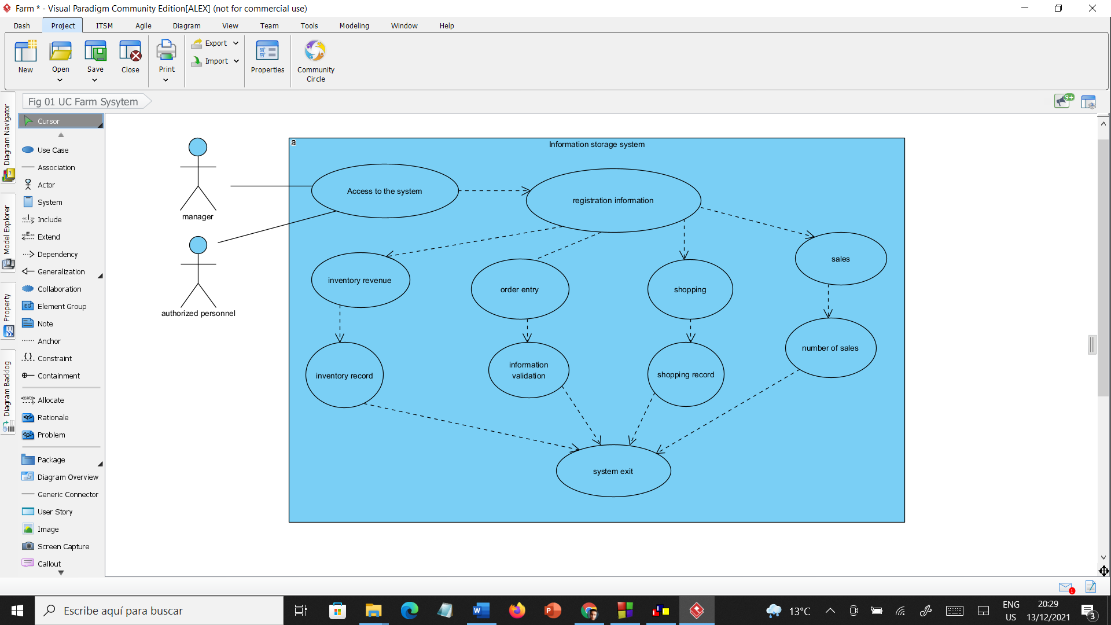

|  | |
| --- | --- |

**2.2.3. Payment Nomainas System**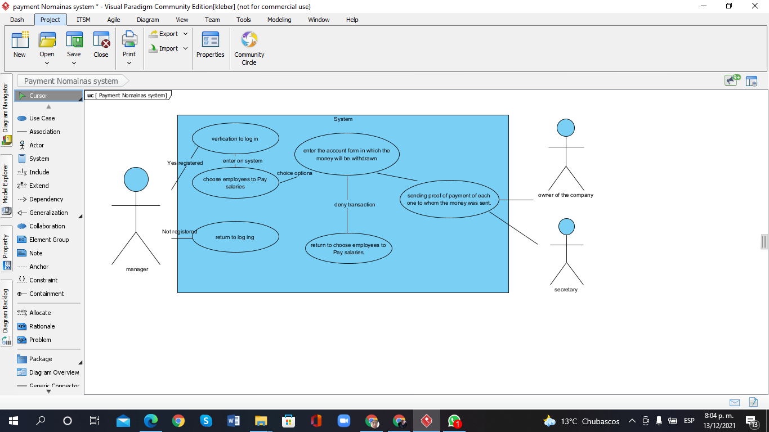

**2.2.4. Sales System**

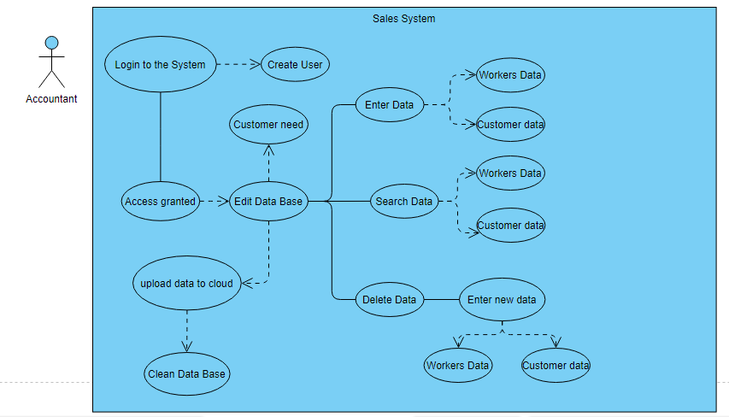

## 2.3 User Classes and Characteristics

Our product is directly aimed at the people in charge of the administrative part of a company, in which the people in charge will be able to administer, edit and search for the necessary information at the time it is needed.

## 2.4 Operating Environment

Our program is based on the administrative, so it will be directed to the administrative and accounting part of a company, maintenance and cleaning of both the program and the included database will be carried out, which includes a section in which data can be saved in the cloud and thus not lose the data registered in the system, in addition, the updates will be carried out as the operation of the program evolves.

## 2.5 Design and Implementation Constraints

The program will have a certain storage space, which at the moment in which there is no space within it, it can be saved in the cloud so as not to lose the progress of data entry to the system, and thus be able to do the respective cleaning and To be able to enter new data, the restrictions that they will have is that only authorized people and those in charge of data management within the company will be allowed to edit it.

## 2.6 User Documentation

What will be delivered as an aid to be able to carry out a good management of our program will be:

1. User manual.

2. Help videos for both the system and the cloud login processes.

3. You will count on our help for maintenance

# 4. System Features

By being able to thicken the characteristics of the system we can emnify the security of the information that will handle the database by integrated antisera a network, of this mantra will be of greater ease to reach communication with other departments as can be in the administrative offices, warehouse, control centers or places of unloading and loading of goods, thus having better control of the information that enters and exits.to this we refer that the software will be able to handle the accounting part, such as the entry and exit of the cachs, balance sheet of investors, costs and expenses, in the administrative areas.

## 4.1 System Feature 1

Rapid response to software, several servicers, cybersecurity, accounting systems.

### 4.1.1 Description and Priority

It keeps a record and accounts of the assets and liabilities of a company, being of medium priority, it benefits that a better management and control of the funds is carried out and the company's situation qualified as a nine, it penalizes the employees who have harmed the company rated as a seven, costs $ 5,000 rated as eight, risk there may be execution errors rated as seven

### 4.1.2 Stimulus/Response Sequences

entering data -> save, sort, search, display, and evaluate data

### 

### 4.1.3 Functional Requirements

| **Requirement ID** | log in | |
| --- | --- | --- |
| **Actors** | Daniel Chiriboga | |
| **Description** | People who want to use the software, whether common or administrative, must register with an account to enter with their username and password and can enter the system. | |
| **Inputs** | username and password | |
| **Departures** | enter of system | |
| **Process** | **Actor**  **username** | **System**   1. **log in username and password** 2. **verification of username** 3. **verification of password** 4. **enter of system** |
| **Preconditions** | the username and password must be previously registered | |
| **Post condicions** | updated data, enabling the functions depending on whether the user is administrative or common | |
| **Alternate flow** | Account recovery in case of forgetting username or password | |
| **Priority** | to have the authorization and to enter the system, the user must be registered, password either administrative or common. | |

| **Requirement ID** | Information storage system | |
| --- | --- | --- |
| **Actors** | Roberto Bedon | |
| **Description** | Users can enter data and important information such as Inventory, supply chain planning, claims processing, order entry, purchases, etc. | |
| **Inputs** | data entry, numerical data entry, | |
| **Departures** | save the information | |
| **Process** | **Actor**  **manager**  **username** | **Sistem**   1. **1. Information input**   **2.information evaluation**  **3. information storage** |
| **Preconditions** | To have the authorization and to enter the system, the user must be registered, contraceña either administrative or common. | |
| **Post condicions** | Updated data | |
| **Alternate flow** | Have a copy or allow easy localization of the information. | |
| **Priority** | Enter the system to enter data, information and records | |

| **Requirement ID** | Payment Nomainas System | |
| --- | --- | --- |
| **Actors** | Kleber chavez | |
| **Description** | is verified, the payment of nomida is made to each of the employees | |
| **Inputs** | Select the employees to be paid, income of the cunta to which it is devitated and enter the value to be paid. | |
| **Departures** | delivery of the receipt for each employee who had his or her salary paid | |
| **Process** | **Actor**  **manager** | System   1. **verification to log in** 2. **choose employees to pay salaries** 3. **enter the account form which the money will be withdrawn** 4. **sending proof of payment of each one to whom the money was sent.** |
| **Preconditions** | administrative user verification and log in | |
| **Post condicions** | keep track of payments and sending proof payment of each one to whom the money was sent | |
| **Alternate flow** | Will not allow you to make any transfer of money if any data is misspelled | |
| **Priority** | have registration and control of payments making it easier to document each one | |

| **Requirement ID** | Sales system | |
| --- | --- | --- |
| **Actors** | Christian Alcocer | |
| **Description** | Manage customers, suppliers and products, which includes the possibility of registering the sales of said products and being able to generate reports about them. | |
| **Inputs** | Username and password | |
| **Departures** | Enter of system | |
| **Process** | **Actor**  **username** | System   1. **Customer Registration** 2. **verification to log in** 3. **product registration** 4. **subtraction in inventory** 5. **collection of the product** |
| **Preconditions** | Have a record of customers, suppliers and authorized personnel, also including the products with a brief description of each one, with prices | |
| **Post condicions** | Enter the necessary data into the database to be able to make the appropriate and necessary report to facilitate the search for each of them | |
| **Alternate flow** | If you enter a wrong or empty data, it will ask for an explanation either to re-enter the data or leave it empty | |
| **Priority** | Enter data in a database to the system | |

# 5. Other Nonfunctional Requirements

## 5.1 Performance Requirements

Within the program, the different functions that we will have will refer to the entry of data into the system, the search for data, the deletion and change of data, a function of being able to extract data and upload it to the cloud, a cleaning of the program's memory in real time, specifically, when both the owner of the program and the user need it.

## 5.2 Safety Requirements

The system has different security measures to prevent, safeguard and protect the information,

Among them the control of access to the system, having the accessibility of entering with a user and password, the confidentiality of the data and the integrity of the user, with this we guarantee the security of the company's system

## 5.3 Security Requirements

The most relevant data of the company will be protected in two directions. On the one hand, with regard to the usurpation of information or unauthorized access to it, as well as the protection of all content.

It will be centralized and will have backup copies scheduled automatically to anticipate any possible incident.

## 5.4 Software Quality Attributes

A special function that our program will have is that when the system memory is full, the entered data can be stored inside the cloud and thus be able to empty the program through cleaning and thus be able to enter new data into the system, and avoid losses both time and data.

## 5.5 Business Rules

Manufacturing: Some of the functions include engineering, capacity, workflow management, quality control, material invoices, manufacturing process, etc.

Finance: Accounts payable, accounts receivable, fixed assets, general accounting and treasury management, etc.

Human Resources: Benefits, training, payroll, hours and attendance, etc.

Supply Chain Management: Inventory, supply chain planning, supplier scheduling, claims processing, order entry, purchases, etc.

Projects: costs, billing, management activity, time and expenses, etc.

# 6. Other Requirements

## 

## Appendix A: Glossary

**SRS:** Software Requirements Specification

**ERP:** Enterprise Resource Planning

## Appendix B: Analysis Models

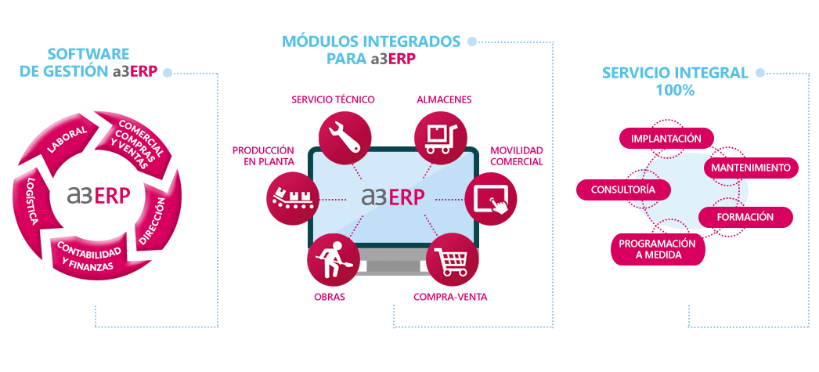

## Appendix C: To Be Determined List

<https://economipedia.com/definiciones/software-de-gestion-empresarial.html#:~:text=Un%20software%20de%20gesti%C3%B3n%20empresarial,log%C3%ADstico%20e%20incluso%20de%20marketing>.